**את"מ מעבדה 11:  
מגישים:  
 אורי מלכא- 314862996   
אלן ציפין- 313206062**DOUBLE:

;

; lab11 ori and alan

; double avg_pows (double arr[], int size);

.MODEL SMALL

.STACK 100h

.DATA

SUM DQ 0 ;We return double

TMP DQ 0 ;

.CODE

_avg_pows PROC NEAR

PUBLIC _avg_pows

;save values

PUSH BP

PUSH SI

MOV BP,SP

; double arr[]=[BP+6]

; int n = [BP+8]

MOV SI,[BP+6]

MOV CX,[BP+8] ;size of array.

RunOnArray:

FLD QWORD ptr[SI] ; ST[0]=arr[i]

FLD QWORD ptr[SI] ; ST[1]=arr[i]

FMUL ; ST[1] =ST[1]*ST[0]=arr[i]*arr[i] ->// pop the stack so ST[0] is our our "powed" arr[i]

FLD SUM

FADD ; ST[0]=SUM+ST[1] ->the next arr[i]^2 that we want to add

FSTP SUM

ADD SI,8

LOOP RunOnArray

FLD SUM ; We want to return in ST[0] our sum

FIDIV WORD PTR[BP+8] ; ST[0] = SUM/size. doesnt pop the stack so we return.

POP SI

POP BP

RET

_avg_pows ENDP

END

FLOAT:  
  
  
  
  
LONG DOUBLE:  
  
  
double input:   
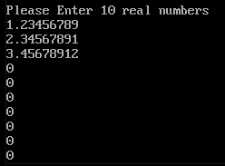  
double output:  
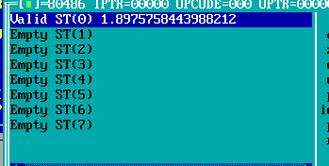  
float input:  
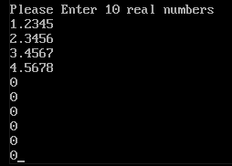  
float output:   
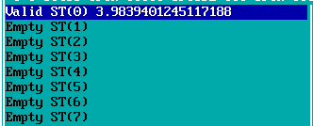  
long double input:  
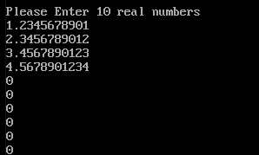long double output:  
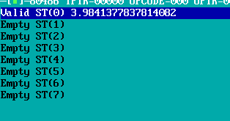

;

; lab11 ori and alan

; float avg_pows (float arr[], int size);

.MODEL SMALL

.STACK 100h

.DATA

SUM DD 0 ;We return float

.CODE

_avg_pows PROC NEAR

PUBLIC _avg_pows

;save values

PUSH BP

PUSH SI

MOV BP,SP

; float arr[]=[BP+6]

; int n = [BP+8]

MOV SI,[BP+6]

MOV CX,[BP+8] ;size of array.

RunOnArray:

FLD DWORD ptr[SI] ; ST[0]=arr[i]

FLD DWORD ptr[SI] ; ST[1]=arr[i]

FMUL ; ST[1] =ST[1]*ST[0]=arr[i]*arr[i] ->// pop the stack so ST[0] is our our "powed" arr[i]

FLD SUM

FADD ; ST[0]=SUM+ST[1] ->the next arr[i]^2 that we want to add

FSTP SUM

ADD SI,4

LOOP RunOnArray

FLD SUM ; We want to return in ST[0] our sum

FIDIV WORD PTR[BP+8] ; ST[0] = SUM/size. doesnt pop the stack so we return.

POP SI

POP BP

RET

_avg_pows ENDP

END

;

; lab11 ori and alan

; long double avg_pows (long double arr[], int size);

.MODEL SMALL

.STACK 100h

.DATA

SUM DT 0 ;We return long double

.CODE

_avg_pows PROC NEAR

PUBLIC _avg_pows

;save values

PUSH BP

PUSH SI

MOV BP,SP

; long double arr[]=[BP+6]

; int n = [BP+8]

MOV SI,[BP+6]

MOV CX,[BP+8] ;size of array.

RunOnArray:

FLD TBYTE PTR [SI] ; ST[0]=arr[i]

FLD TBYTE PTR [SI] ; ST[1]=arr[i]

FMUL ; ST[1] =ST[1]*ST[0]=arr[i]*arr[i] ->// pop the stack so ST[0] is our our "powed" arr[i]

FLD SUM

FADD ; ST[0]=SUM+ST[1] ->the next arr[i]^2 that we want to add

FSTP SUM

ADD SI,10

LOOP RunOnArray

FLD SUM ; We want to return in ST[0] our sum

FIDIV WORD PTR[BP+8] ; ST[0] = SUM/size. doesnt pop the stack so we return.

POP SI

POP BP

RET

_avg_pows ENDP

END